**SD03Q02**

**Question 2:**

**Social Network Ads**

**Cell 1:**

Importing the dataset and viewing it.

**Cell 2:**

Creation of dependent variable and independent variable in an array.

**Cell 3:**

Splitting the dataset into

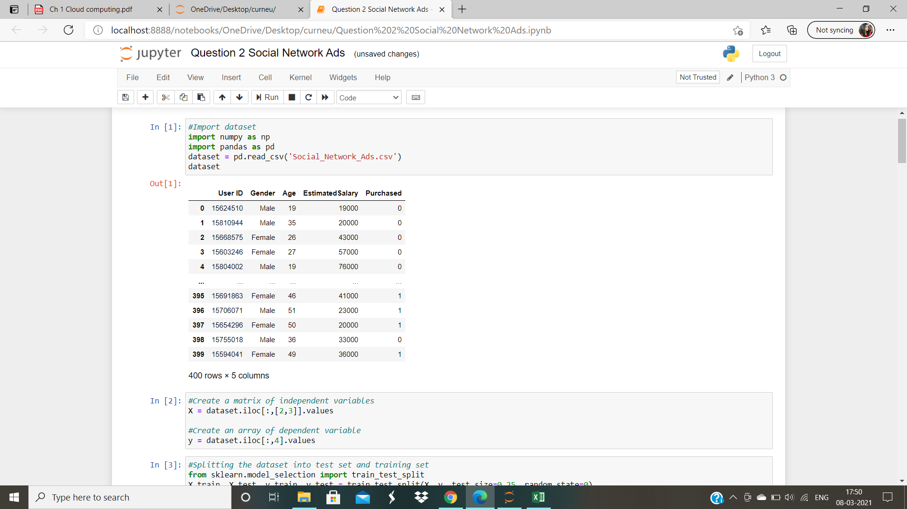

**Cell 4:**

Feature the scaling using standard scaler

**Cell 5 & 6:**

Generating the tree using ID 3 Algorithm and for that we are working on the function entropy.

**Cell 7:**

Function of Information Gain

**Cell 8:**

Function of ID3 Algorithm to generate the tree

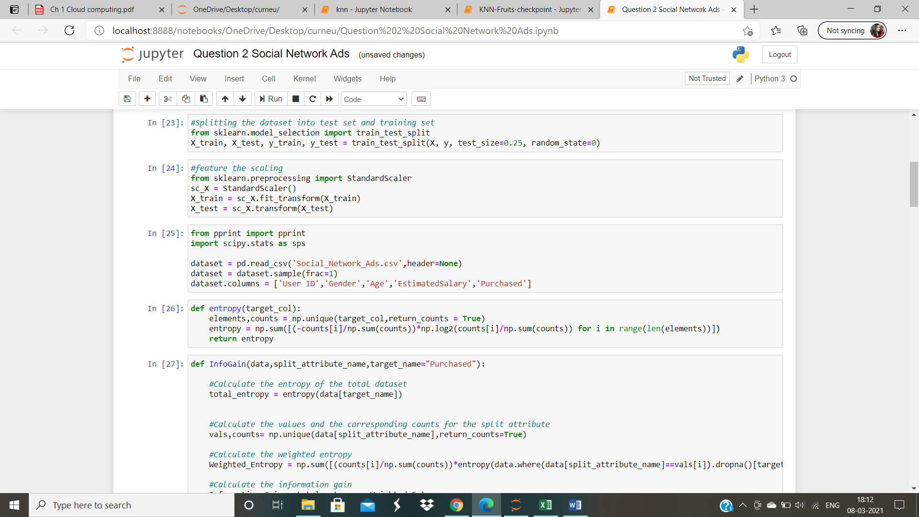

**Cell 9:**

Snippet of the code to predict

**Cell 10:**

working on the train test split data

**Cell 11:**

Training the random forest model

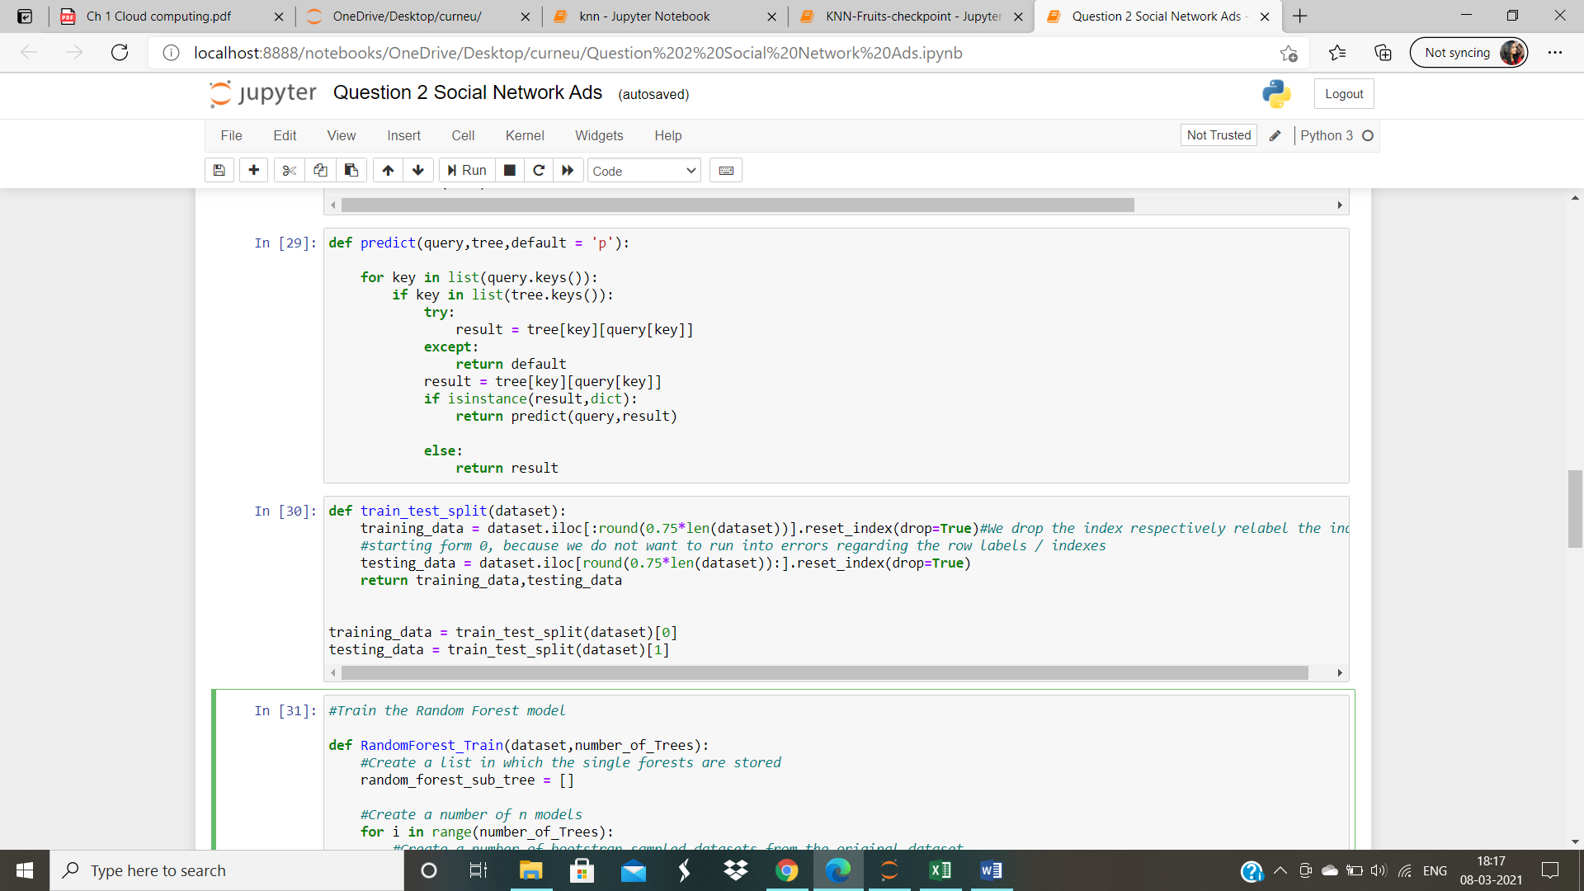

**Cell 12:**

Prediction using the random forest to an instance

**Cell 13:**

Using the random forest classifier to classify

**Cell 14 & 15:**

Generating the confusion matrix

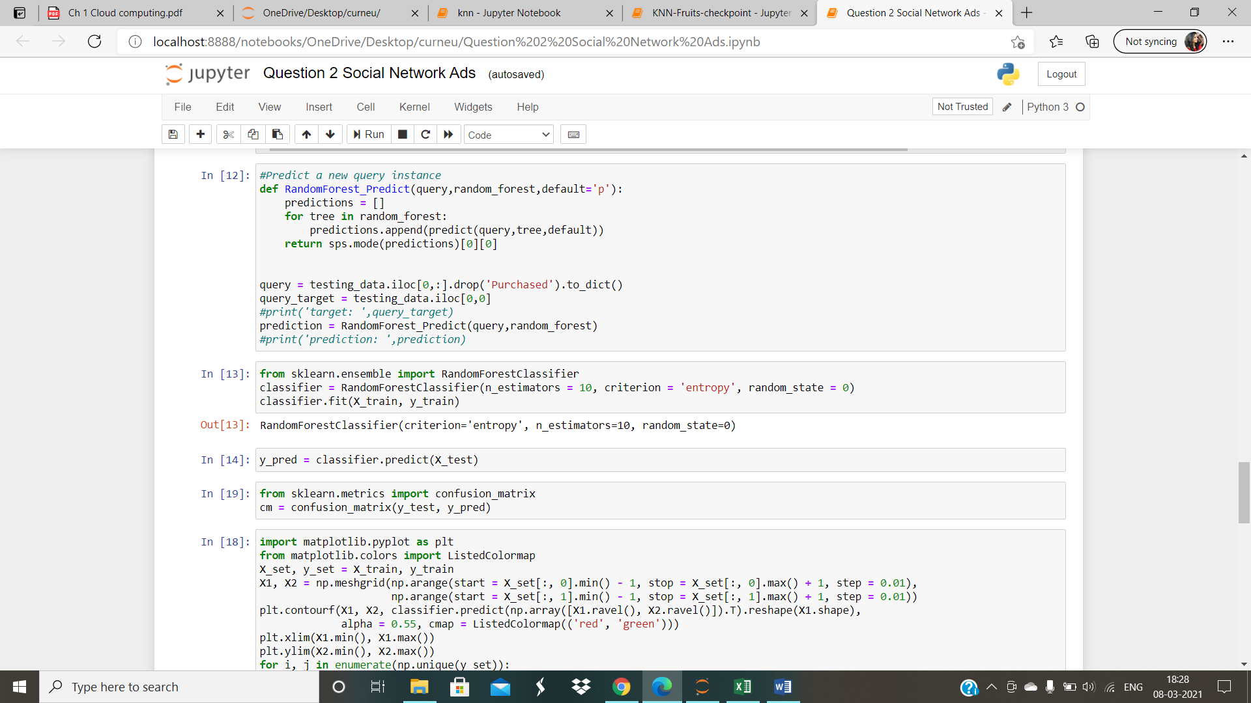

**Cell 16:**

Graph plotted for training dataset

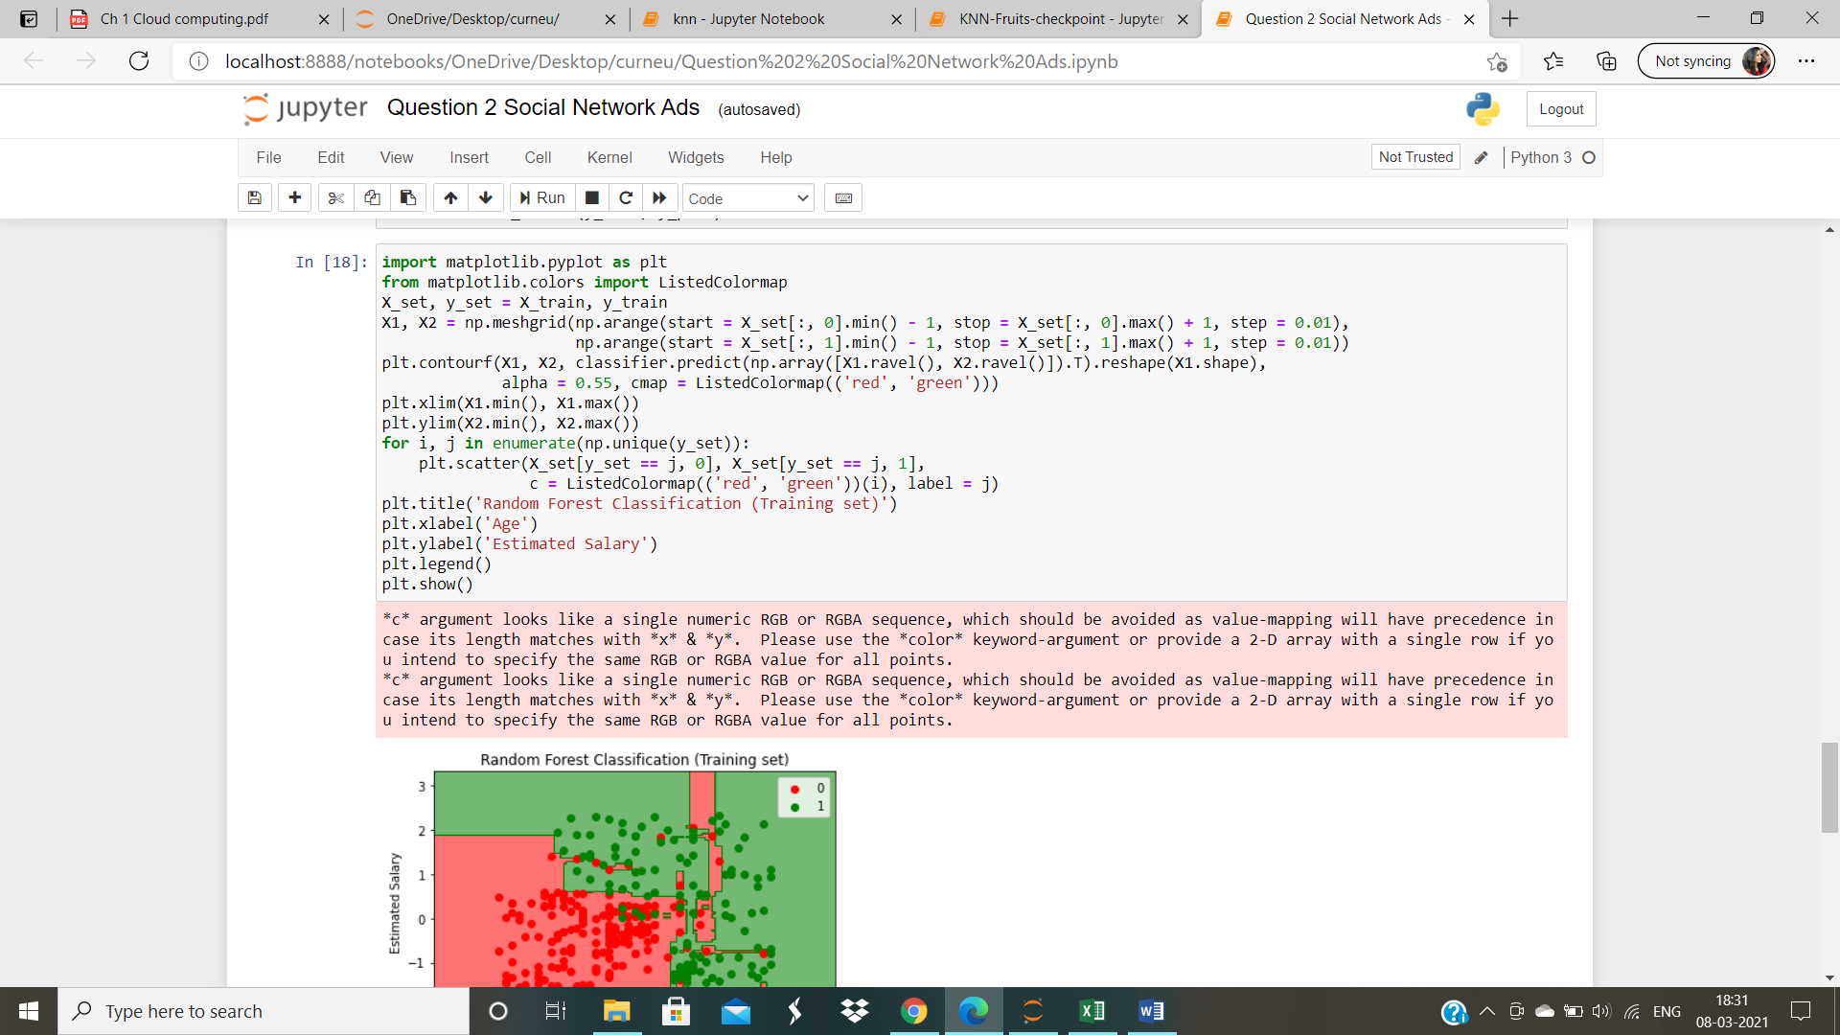

**Cell 17:**

Graph plotted for the test dataset

